**Structure of Invoicing**

Add an Invoicing Type Fields in Customer Master in drop-down with following values:

1. Fixed Wise Rate.
2. Sample Wise Rate.
3. Sample & Parameter Wise Rate.
4. ITC Wise Standard Rate.
5. PO wise invoicing.
6. **Fixed Rate Parties:**

* Have fixed amount irrespective of product name & no. of parameters to be test. Fixed amount will be defined in the customer master.

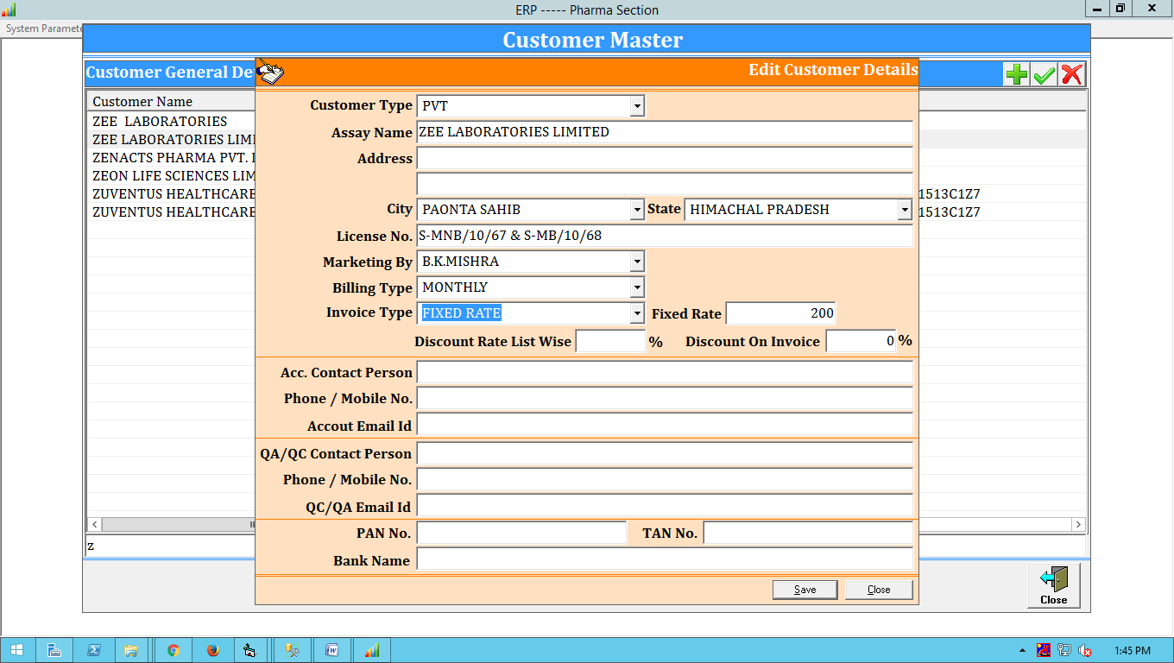

1. **Sample Wise Rate**:

* Sample Master for product names to be created in which we define names of those product whose rates are product wise irrespective of customer name.
* This product list is co-related with the product master.i.e. these product names are the clones/alias of the existing product master.
* ***State wise rate list***: In the case of state wise rate list, their rates should be defined state wise and then that rate list is allocated to multiple parties belong to that state by the system on the selection of party.

**Step 1:** Create Standard Customer Product Master by using Product Master having multiple alias name of One Product Name.

**Step 2:** Then assign the Standard Customer Product Master to States.

**Step 3:** Create a form having:

* State Dropdown with Multiple Selection Option
* Sample Product Dropdown with Multiple Selection Option
* Customer Dropdown with Multiple Selection Option if same sample rates are applicable to the customer.

**Step 4:** Save Button.

Tables:

* Customer Sample Masters:

Fields:

sample_master_id(Auto-increment),

product_id,

sample_master_name,

sample_master_status,

created_at,

updated_at

* Customer Sample State Rates:

Fields:

sample_state_rate_id(Auto-increment),

state_id,

sample_master_id,

sample_rate

sample_state_status,

created_at,

updated_at

* Customer Invoicing Rates:

Fields:

customer_rate_id(Auto-increment),

Invoicing_type_id,

state_id,

city_id,

customer_id,

sample_master_id,

rate

created_at,

updated_at

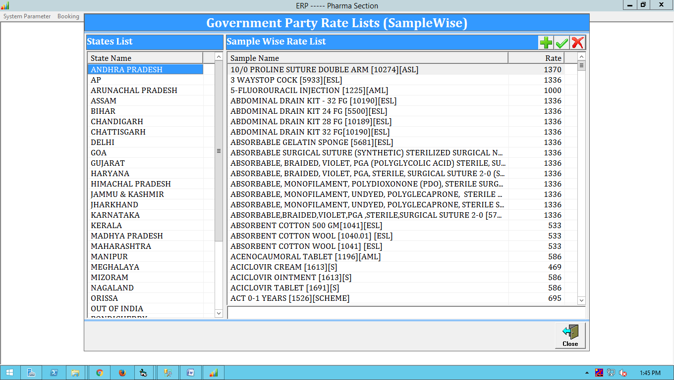

* ***Party Name & Place wise: -***Rate list is created party name and place wise.

**Step 1:** Create Standard Customer Product Master by using Product Master having multiple alias name of One Product Name with their Price rate.

**Step 2:** Then assign the Standard Customer Product Master to States.

**Step 3:** Create a form having:

* State Dropdown with Multiple Selection Option
* City Dropdown with Multiple Selection Option with respect to State.
* Customer Dropdown with Multiple Selection Option if same sample rates are applicable to the customer.
* Sample Product Dropdown with Multiple Selection Option.

**Step 4:** Save Button.

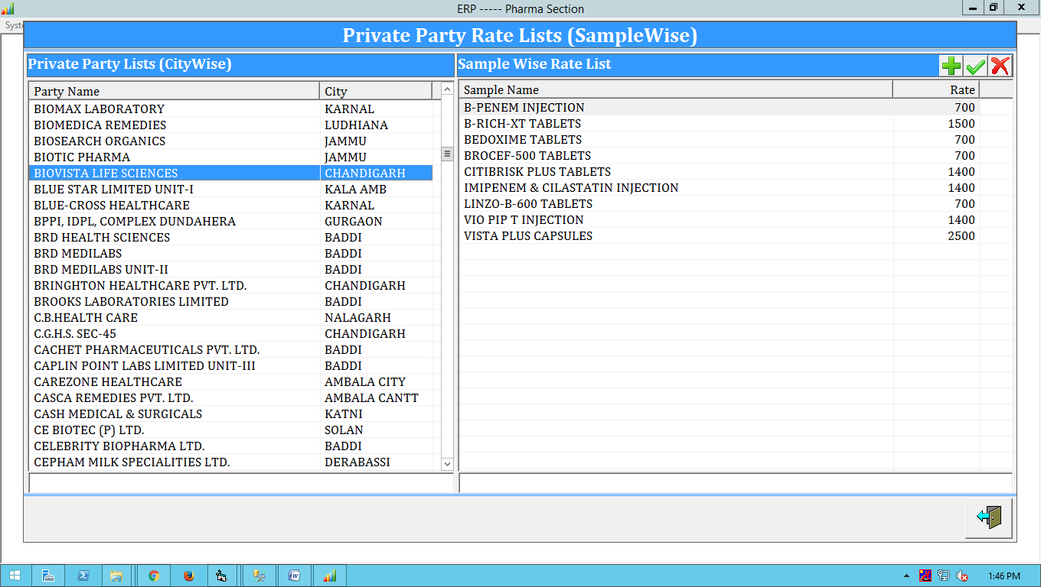

1. **Parameter wise rate list:**

* First we will create standard rate list of organization department wise. then it will be allocated to the the parties.

Note: - Also required allocation of same rate list to the multiple parties on single click.

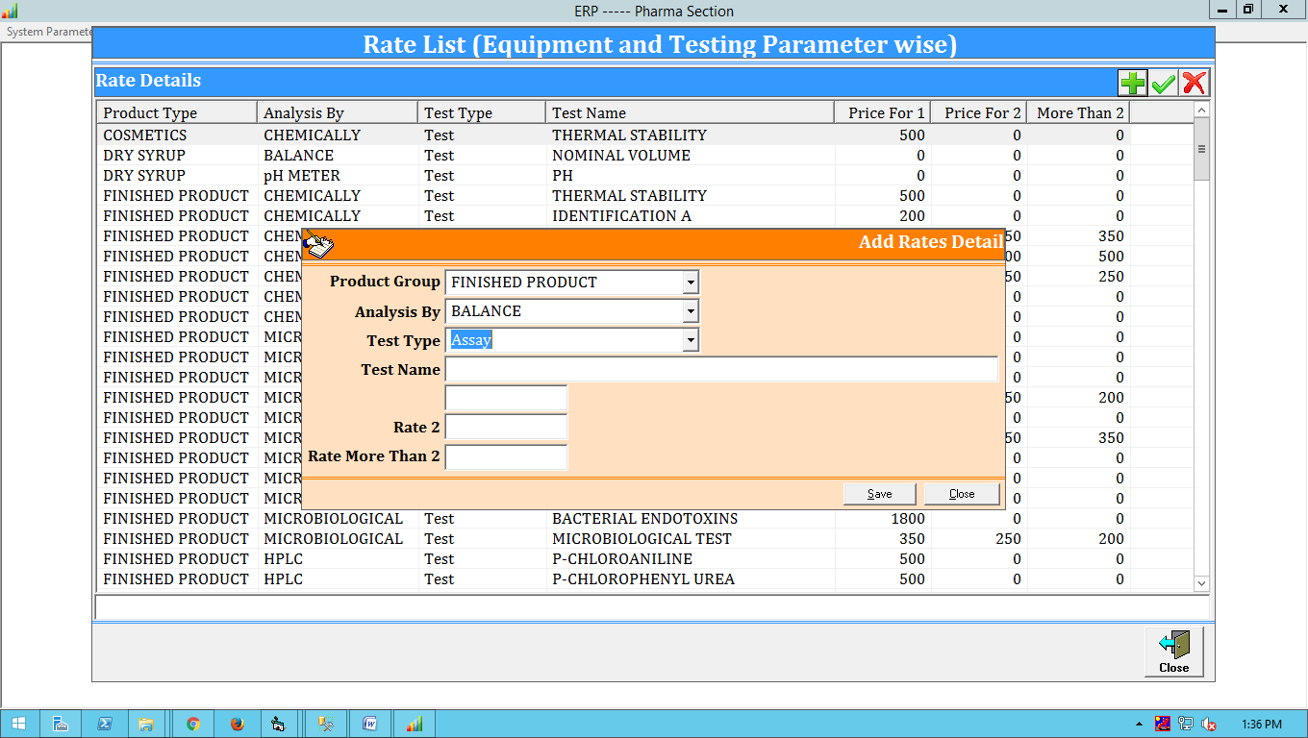

* Allocation to Party: -

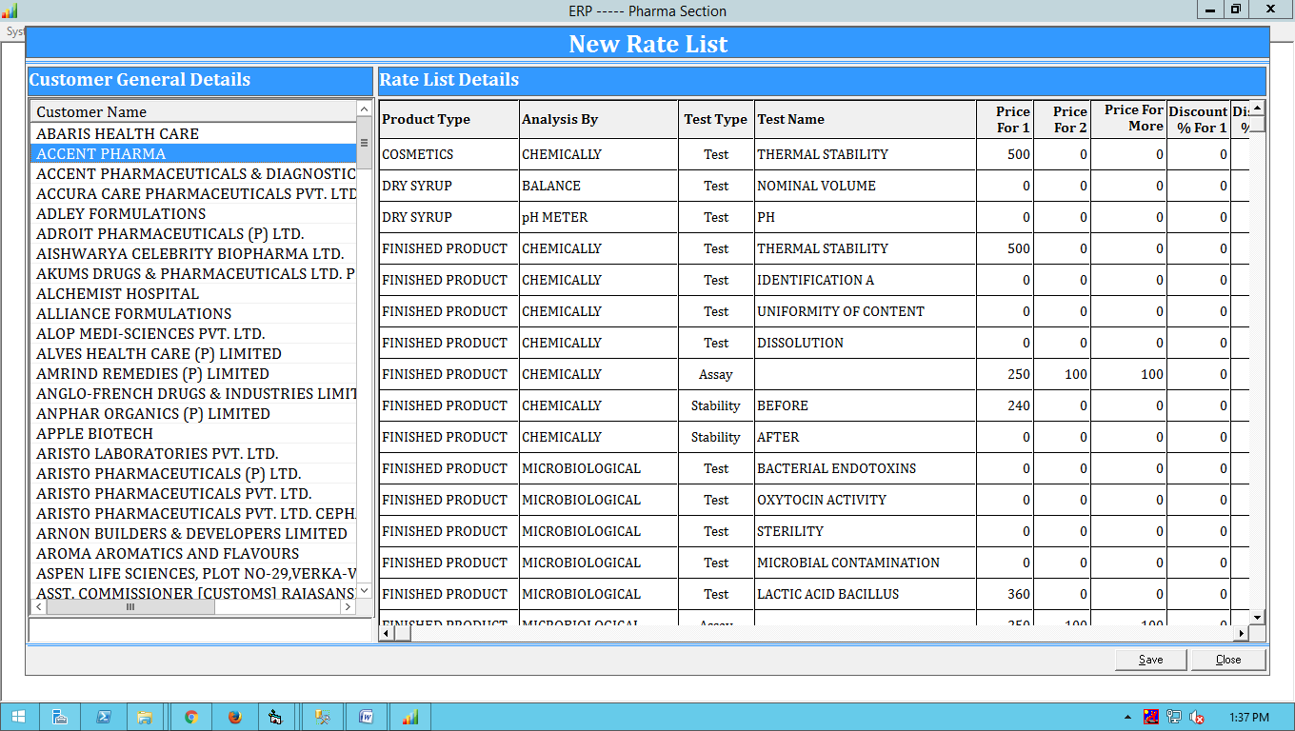

After discussion the with Chand Sir,

Add an Invoicing Type Fields in Customer Master in drop-down with following values:

1. ITC-Parameter Wise
2. State wise Product
3. Customer Wise Product / Fixed rate customer
4. Customer wise Parameters

----------